Student Name (1): Fabro, Cyril Efren SN (1): 6243515

Student Name (2): Morin, Jonathan SN (2): 6240678

LAB-9 In-class Exercise
Three percent (3%) of the final Grade
Submit Your Completed LAB – by End of Day October 31, 2025

Use the LAB 9 Packet Tracer provided with this assignment
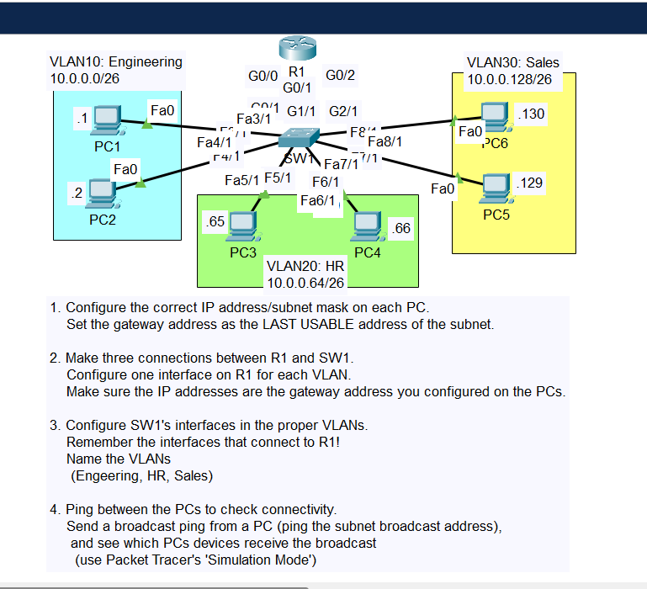

LAB Objective
- Start Cisco Packet Tracer
- Your goal is to construct the network depicted above using Cisco Packet Tracer, to configure Switch VLANs and Access Ports, and test connectivity, by pinging host and router interfaces.
- Configure Hosts, Routers with proper IP addresses as in the supplied Packet Tracer
- Run command show vlan brief on each of the VLANs prior to configuration
- Configure all of the VLANs with appropriate access ports.
- Name the VLAN based on the departments
- Run command show vlan brief on each of the VLANs. once it is completed and tested for connectivity.
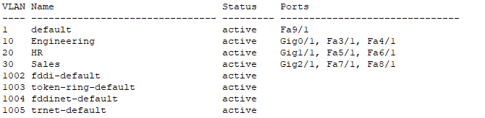

End of assignment

